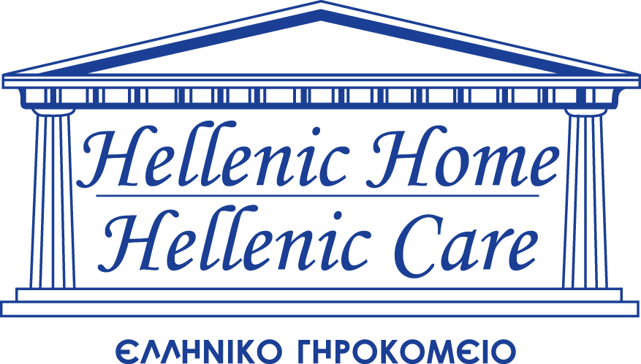 GIFT COMMITMENT FORM

GIFT INFORMATION

I/We are pleased to support the Hellenic Home for the Aged with a gift of $________________________.

My gift will be: one time gift pledge pledge with initial payment of $____________________enclosed.

Installments of $ beginning on _____________________will be made:

Monthly Quarterly Semi-annually Annually, over a period of One Three or Five years.

I/We would like the gift designated to:

Hellenic Home (general) Hellenic Care Toronto Hellenic Home Scarborough

Scarborough Chapel Toronto Chapel I would like to reserve the following icon_____________________
This gift is in: honour of Name of Honouree :_______________________________________
Address/Postal Code/Phone Number (of honouree) ______________________________________________________________
memory of Name of Deceased: _____________________________________________
Name/Address/Postal Code/Phone Number (to send condolence card)
________________________________________________________________________________________________________
A letter of thanks along with an official receipt for Income Tax purposes will be sent to you
PAYMENT OPTIONS

I/We prefer to make our donation by:

Cheque enclosed payable to The Hellenic Home for the Aged Inc.

Credit card: Visa MasterCard Name on Card: _______________________________________

Card Number: Expiry Date: Signature: _________________________________
(Month/Year)

I/we authorize Hellenic Home for the Aged to charge my/our pledge amount to my/our credit card at the frequency listed above in Gift Information. Signature: ________________________________________________

DONOR INFORMATION

Mail pledge reminders and/or official receipts to:
Name: Address: _________________________________________________
City: ______________________ Province: ____________ Postal Code: ______________ Phone Number: ________________ Fax Number: _______________________ Email: _______________________________ Date: __________________________

In all Donor Recognition associated with this gift, please list the Donor as:

I/We prefer to remain anonymous

Please mail or fax this form to: The Hellenic Home for the Aged Inc. 33 Winona Drive, Toronto, ON M6G 3Z7 Phone (416) 654-7700 Fax: (416) 654-0943
Attention: Patty Agrapidis, Special Events & Annual Giving Coordinator

Thank you for your thoughtful donation. Your support will enable Hellenic Home for the Aged Inc., to continue providing exceptional care and services to our seniors.
Charitable Business Number: 107476053 RR0001

